Creating Electric Circuits
Electric circuits are in everything from telephones to the wiring of an entire house. In this lesson, you will investigate both a series circuit and a parallel circuit.

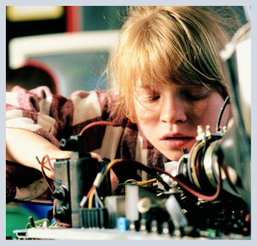

Parts of a Circuit
A circuit is a continuous loop of electric current. Take a minute to review the parts of a circuit.
electron source: a battery that provides electrical current
electron loop: wires to make a loop so that the electrons can travel around the circuit
resistor: a light bulb or other device that converts some of the energy in the circuit to light or thermal energy

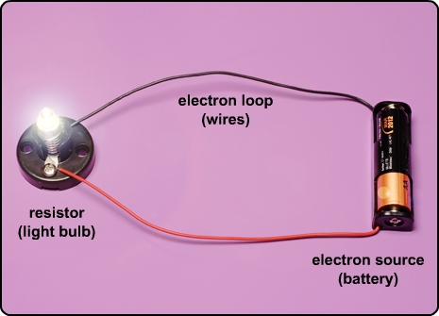

Open and Closed Circuits
Electric current will only flow if the circuit is closed, like the one in the diagram on the left.
An open circuit, as shown in the diagram on the right, stops the flow of electrons where the circuit is broken, or when the switch is open.

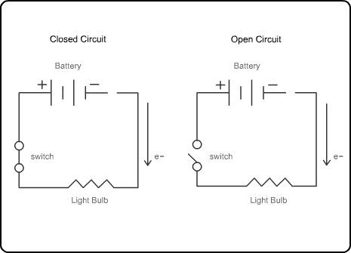

Series vs. Parallel
In a series circuit, the current flows through a resistor (light bulb) to a conductor that leads to the next bulb, all the way down the line. In a parallel circuit, the current can follow multiple paths.
In this lesson's activity, you will make both types of circuits. Select the plus signs to view the schematic—also known as the diagram of the circuit.

Slideshow: Parallel Circuit

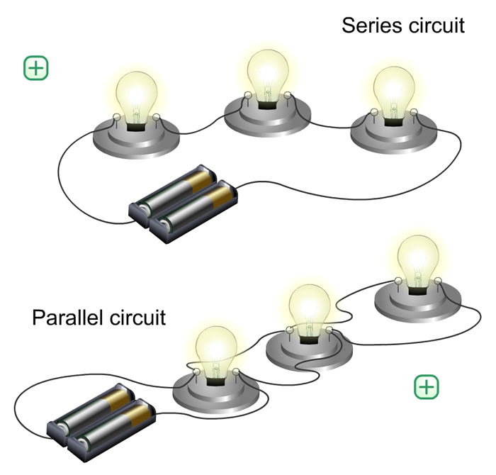
An illustration of series circuit and parallel circuit

An illustration of series circuit and parallel circuit with a series circuit pop-up diagram. All resistors are in a row.

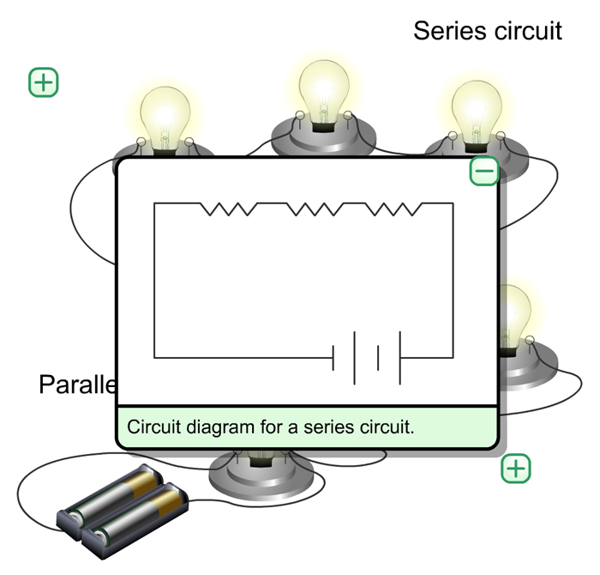
Circuit diagram for a series circuit.

An illustration of series circuit and parallel circuit with a parallel circuit pop-up diagram. Resistors are parallel to one another, each connected directly to the battery.
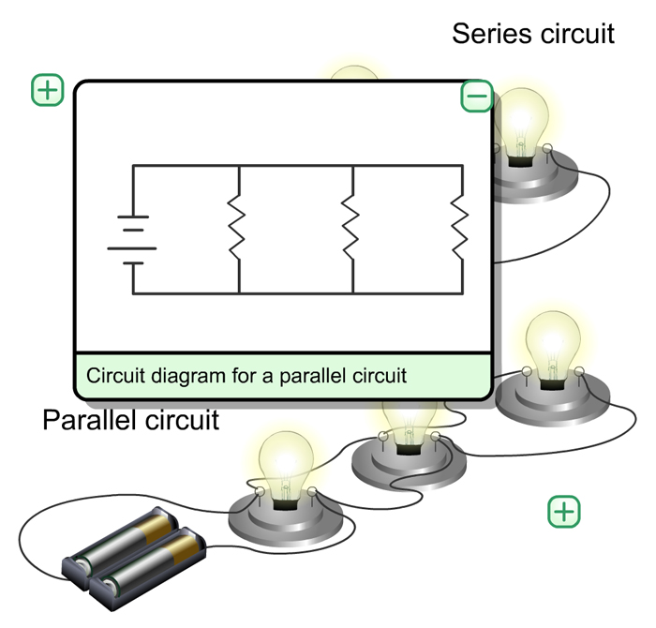
Circuit diagram for a parallel circuit.

Series vs. Parallel
In the last lesson, Arnold built an open circuit and a closed circuit, otherwise known as a simple circuit. Now he wants to use that basic design to construct two different types of circuits—a series circuit and a parallel circuit.
A series circuit has all of the bulbs placed along the same circuit in a line. If one bulb burns out or doesn’t work, none of the bulbs will light. A parallel circuit has bulbs placed parallel to each other. If one bulb burns out or doesn’t work, the rest of the bulbs in the circuit will still light. Think about the lights in your home. If one bulb in one lamp burns out, do the rest of the lights in your home still work? The rest of the bulbs still work because they are on a parallel circuit.

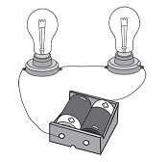
Series Circuit

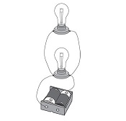
Parallel Circuit

Example Problem: Building a Series Circuit

Directions: View each step below in the example problem.

Second Lamp
Arnold began with his simple circuit.
He disconnected the black alligator clip from the screw on one side of the lamp socket.
He screwed a second light bulb into the second lamp socket.
He then took a third length of wire and attached the first end to the second screw in the first lamp socket. The second end he secured under one screw in the second lamp socket.
He then secured the black alligator clip to the remaining screw on the second socket. This is what he observed.

Image shown is a picture of a simple circuit. Two batteries are shown connected in a battery cradle. An alligator clip in red with wire is shown connected to one terminal of the cradle, and another in black is shown connected to the other terminal of the cradle. The alligator clip in red is shown to directly connect to wire with an open end having a paper clip attached to the wire end. The alligator clip in black is shown to connect to a light bulb setup that is further connected directly to yet another light bulb set up. This second light bulb is then directly connected to wire with an open end having a paper clip attached to the wire end.

Closed Circuit
Arnold then placed the metal bar across the two paper clips, and this is what he observed.

Image shown is a picture of a simple circuit. Two batteries are shown connected in a battery cradle. An alligator clip in red with wire is shown connected to one terminal of the cradle, and another in black is shown connected to the other terminal of the cradle. The alligator clip in red is shown to directly connect to wire with an open end having a paper clip attached to the wire end. The alligator clip in black is shown to connect to a light bulb setup that is further connected directly to yet another light bulb set up. This second light bulb is then directly connected to wire with an open end having a paper clip attached to the wire end. The two paper-clipped ends of the two wires are connected using a metal bar, which is shown to lay across the two paper clips, joining them.

Problem
Arnold had expected both lights to light up, but nothing happened! Arnold remembered from the previous investigation how to troubleshoot the circuit, so he followed those steps. He identified the problem as the second lamp socket; everything else worked.

Image shown is a picture of a simple circuit. Two batteries are shown connected in a battery cradle. An alligator clip in red with wire is shown connected to one terminal of the cradle, and another in black is shown connected to the other terminal of the cradle. The alligator clip in red is shown to directly connect to wire with an open end having a paper clip attached to the wire end. The alligator clip in black is shown to connect to a light bulb setup that is further connected directly to yet another light bulb set up. This second light bulb is then directly connected to wire with an open end having a paper clip attached to the wire end. The two paper-clipped ends of the two wires are connected using a metal bar, which is shown to lay across the two paper clips, joining them. The two light bulb set ups are shown to not light up, but remain dark.

The Solution
Arnold realized that the lamp socket made it easier to make the connections with the wires, but that he could still make the connections without the lamp socket. He took the bare end of the wire that had been looped around the lamp socket screw, and using his small pliers, wrapped the end around the side of the metal portion of the bulb. He was very careful not to break the bulb.

Image shown is a picture of a simple circuit. Two batteries are shown connected in a battery cradle. An alligator clip in red with wire is shown connected to one terminal of the cradle, and another in black is shown connected to the other terminal of the cradle. The alligator clip in red is shown to directly connect to wire with an open end having a paper clip attached to the wire end. The alligator clip in black is shown to connect to the metal bottom portion of a light bulb that is further connected directly to a light bulb set up (with socket). This second light bulb (with socket) is then directly connected to wire with an open end having a paper clip attached to the wire end.

The Results
Arnold found that he could balance the light bulb on the surface of the alligator clip. Now when he placed the bar across the two paper clips, the light bulbs did light up. This is what he observed.

Image shown is a picture of a simple circuit. Two batteries are shown connected in a battery cradle. An alligator clip in red with wire is shown connected to one terminal of the cradle, and another in black is shown connected to the other terminal of the cradle. The alligator clip in red is shown to directly connect to wire with an open end having a paper clip attached to the wire end. The alligator clip in black is shown to connect to the metal bottom portion of a light bulb that is further connected directly to a light bulb set up (with socket). This second light bulb (with socket) is then directly connected to wire with an open end having a paper clip attached to the wire end. The two paper-clipped ends of the two wires are connected using a metal bar, which is shown to lay across the two paper clips, joining them. The first light bulb (without socket) is shown having lighted up, however the second light bulb (with socket) is shown to light up very dim.

Up Close
Arnold was still a bit surprised by what he saw, so he took a closer look. What do you think surprised Arnold?

A close up of the light bulb portion of the circuit is shown. The first light bulb (without socket) is shown having lighted up, however the second light bulb (with socket) is shown to light up very dim.

One Bulb
Arnold left the circuit in connected and removed the light bulb that was in the lamp socket. This is what he observed.

Image shown is a picture of a simple circuit. Two batteries are shown connected in a battery cradle. An alligator clip in red with wire is shown connected to one terminal of the cradle, and another in black is shown connected to the other terminal of the cradle. The alligator clip in red is shown to directly connect to wire with an open end having a paper clip attached to the wire end. The alligator clip in black is shown to connect to the metal bottom portion of a light bulb that is further connected directly to a light bulb set up (with socket but no light bulb). This second light bulb socket is then directly connected to wire with an open end having a paper clip attached to the wire end. The two paper-clipped ends of the two wires are connected using a metal bar, which is shown to lay across the two paper clips, joining them. The first light bulb (without socket) is not shown to light up – but remains dark.

Example Problem: Building a Parallel Circuit

Directions: View each step below in the example problem.

Build Circuit
Before Arnold attempted the second part of his investigation, he asked his mom to take him to the store to buy new lamp sockets. Arnold then followed the instructions to build the parallel circuit. He noticed that the switch and the battery together were wired in parallel to the first light socket.

Image shown is a picture of a parallel circuit. Two batteries are set into a battery cradle. Two wires radiate from the two terminals of the battery cradle. One of the wires that radiates from the battery cradle is connected directly to a paper clip that is not connected to anything else. The other wire radiating from the battery cradle is shown to be split, with part of it going to one light bulb socket (containing a light bulb) and the other part going to yet another light bulb socket (containing another light bulb). Both light bulb sockets are connected to a single paper clip that is not connected to anything else.

Closed Circuit
Arnold placed the metal bar across the two paper clips to close the circuit. This is what he observed.

Image shown is a picture of a parallel circuit. Two batteries are set into a battery cradle. Two wires radiate from the two terminals of the battery cradle. One of the wires that radiates from the battery cradle is connected directly to a paper clip. The other wire radiating from the battery cradle is shown to be split, with part of it going to one light bulb socket (containing a light bulb) and the other part going to yet another light bulb socket (containing another light bulb). Both light bulb sockets are connected to a single paper clip. The two terminal paper clips are shown connected by a metal bar. The two light bulbs of the two light bulb sockets are shown to light up equally bright.

Remove Light 1
Arnold removed the metal bar and then removed the light from the first light socket. After replacing the metal bar, this is what he observed.

Image shown is a picture of a parallel circuit. Two batteries are set into a battery cradle. Two wires radiate from the two terminals of the battery cradle. One of the wires that radiates from the battery cradle is connected directly to a paper clip. The other wire radiating from the battery cradle is shown to be split, with part of it going to one light bulb socket (containing a light bulb) and the other part going to yet another light bulb socket ( but not containing another light bulb). Both light bulb sockets are connected to a single paper clip. The two terminal paper clips are shown connected by a metal bar. The light bulb socket containing the light bulb is shown to shine brightly even though the other light bulb socket contains no light bulb.

Both Lights
Arnold again removed the metal bar, screwed the first light back into the light socket, and then replaced the metal bar. This is what Arnold observed.

Image shown is a picture of a parallel circuit. Two batteries are set into a battery cradle. Two wires radiate from the two terminals of the battery cradle. One of the wires that radiates from the battery cradle is connected directly to a paper clip. The other wire radiating from the battery cradle is shown to be split, with part of it going to one light bulb socket (containing a light bulb) and the other part going to yet another light bulb socket (containing another light bulb). Both light bulb sockets are connected to a single paper clip. The two terminal paper clips are shown connected by a metal bar. The two light bulbs of the two light bulb sockets are shown to light up equally bright.

Remove Light 2
Arnold removed the metal bar again and then unscrewed the light from the second light socket. After replacing the metal bar, this is what he observed.

Image shown is a picture of a parallel circuit. Two batteries are set into a battery cradle. Two wires radiate from the two terminals of the battery cradle. One of the wires that radiates from the battery cradle is connected directly to a paper clip. The other wire radiating from the battery cradle is shown to be split, with part of it going to one light bulb socket (containing a light bulb) and the other part going to yet another light bulb socket ( but not containing another light bulb). Both light bulb sockets are connected to a single paper clip. The two terminal paper clips are shown connected by a metal bar. The light bulb socket containing the light bulb is shown to shine brightly even though the other light bulb socket contains no light bulb.

Both Lights
Arnold again removed the metal bar, screwed the second light back into the light socket, and then replaced the metal bar. This is what Arnold observed.

Image shown is a picture of a parallel circuit. Two batteries are set into a battery cradle. Two wires radiate from the two terminals of the battery cradle. One of the wires that radiates from the battery cradle is connected directly to a paper clip. The other wire radiating from the battery cradle is shown to be split, with part of it going to one light bulb socket (containing a light bulb) and the other part going to yet another light bulb socket (containing another light bulb). Both light bulb sockets are connected to a single paper clip. The two terminal paper clips are shown connected by a metal bar. The two light bulbs of the two light bulb sockets are shown to light up equally bright.

Assignment: Circuits Investigation
Use your observations to answer the questions about creating a circuit and about series and parallel circuits.

